**The Rainhill Trials Worksheet** (Version 2)  
  
In 1829 the building of the Liverpool to Manchester railway was nearly complete. The owners of the new railway were unsure which type of train should run on the new train line. They created a competition to help them decide which was the most suitable and fastest train. The winning train would not only be chosen to run on the line, but it would also win £500 prize money.

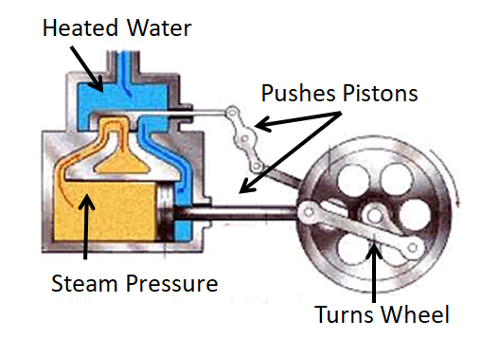The competition at Rainhill took nine days to complete and over 10,000 people turned up to watch. Rather than travel the whole distance from Liverpool to Manchester,   
each train was required to travel back and forth along a much shorter 1 mile track. This was to re-create the total 30-mile distance between the two cities.

Five trains took part in the Rainhill Trails.   
They were: *The Novelty, The Perseverance,   
The Sans-Pareil, The Cycloped* and *The Rocket*.  
  
Four of the five were machines that were powered by steam.   
They all had small coal fires on them that would heat water. The steam from the water would be fed into cylinders,   
the force of the steam would push metal pistons around   
which in turn would make the wheels turn.

The Cycloped was the strangest of all the completion entries and was operated not by steam, but by a horse. The horse ran on a conveyor belt, like a treadmill in a gym. This movement pulled the train wheels along the track.

The winner of the completion was of course The Rocket.   
It covered the 30 miles of track in 3 hours.   
It reached a speed of 12 miles per hour   
but later it would go on to double this speed.

The Rocket was created by father and son team George and Robert Stephenson. Father, George Stephenson had already worked on the actual building of the train track between Liverpool and Manchester. It was his son Robert that designed and made the actual Rocket train. Less than a year later and The Rocket would make history as the first-ever train in the world to carry both goods and people.

**Questions are on the next page**

**The Rainhill Trials** **Questions**

|  |
| --- |
| 1. How **much money** was given to the winner of the Trails? |

|  |
| --- |
| 2. How many **round trips** (back and forth journeys)  would a train need to do on a **1 mile track** to complete **30 miles** in total? |

|  |
| --- |
| 3. Explain how **steam power** works |

|  |
| --- |
| 4. What **problems** could happen with the horse-draw ***Cycloped*** train**?** |

|  |
| --- |
| 5. What **experience** did George Stephenson have **before** the Rainhill trails? |