**The Rainhill Trials Worksheet** (Version 1)  
  
  
The Rainhill Trials was a **competition** to see   
what the **fastest train** was.  
  
It took place in **1829** at **Rainhill**,   
a small village just outside Liverpool.  
  
The owners of the Liverpool to Manchester **trainline** needed to **choose a train** to run on it.  
  
The winning train would **run on the new line**   
and also win **£500** prize money.

There were five trains taking part:

They were: *The Novelty, The Perseverance,   
The Sans-Pareil, The Cycloped* and *The Rocket*.  
  
The **Cycloped** train had a **horse** ran on a conveyor belt.

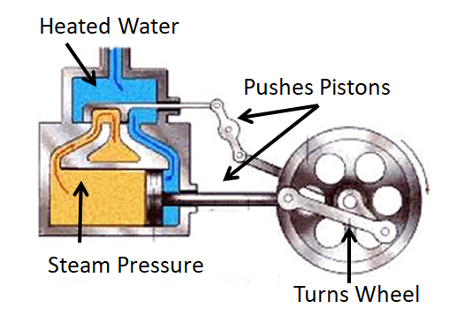The **movement** of the horse walking pushed the train along.

  
The other trains were powered by steam.   
  
A small coal fire on the train would heat water. The steam from the water would push metal pistons around which would make the wheels turn.  
  
  
The winner of the completion was **The Rocket**.  
   
The Rocket was created by father and son team **George** and **Robert Stephenson**.   
  
The Rocket became the first-ever train in the world to carry people.

**Questions are on the next page**

**The Rainhill Trials** **Questions**

|  |
| --- |
| 1. What were the **Rainhill Trials**? |

|  |
| --- |
| 2. What did the **winner** of the Trails get? |

|  |
| --- |
| 3. Explain how **steam power** works |

|  |
| --- |
| 4. What **problems** could happen with the horse-draw ***Cycloped*** train**?** |

|  |
| --- |
| 5. Who made **The Rocket** train? |