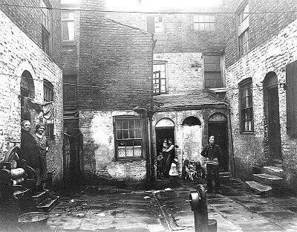Poverty and disease in Victorian Liverpool (**Worksheet Version 2)**

With the growth of the shipping port and the arrival of the railways, Victorian Liverpool grew very quickly. Many people who used to work in the countryside suddenly moved to Liverpool for better paid work and a better life.   
  
10,000 people a year moved to Liverpool at this time. Because there wasn’t enough houses for people to live in, small, quickly-built houses were created. These were very cramped and had no inside toilets. The dark, damp, overcrowded houses were known as slums.   
  
People had lots of children at that time and a family of up to ten people would often be found living in one tiny two-room house.

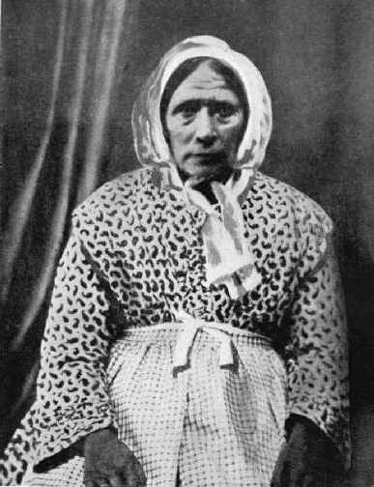The slums all had a central shared courtyard. This was not a place to play, but more used as a large sewer were food and toilet waste was thrown. In the central courtyard was also a water pump that everyone would share.  
  
No-one had indoor water taps. Instead, a shared outside pump was used. Disease spread quickly in the slums and in 1832 an outbreak of cholera happened. This is a deadly disease that spreads through bacteria in water.

The cholera outbreak was stopped by the creation of a wash-house and laundry. A woman named Kitty Wilkinson set up a place that people could wash their clothes and themselves with chlorine (bleached water) and this helped to reduce the spread of the cholera bacteria.

In early Victorian times, very few children went to school, most worked in factories. If you did go to school it would often be in one small building with just one classroom. One class could have lots of different ages in it.   
  
At first, only those who could afford it could send their children to school. It wasn’t until 1870 that all children could go to school, but even then most left by the age of 10. The teachers were very strict and would often hit children very hard if they did not do as they were told.

**Questions are on the next page**

Poverty and disease in Victorian Liverpool **Questions**

|  |
| --- |
| 1. **Why** did so many people **move** to Liverpool in Victorian Times? |

|  |
| --- |
| 2. **What** do you think **life would be like** living in a poor **slum house**? |

|  |
| --- |
| 3. What is **cholera** and how did it **spread**? |

|  |
| --- |
| 4. What did **Kitty Wilkinson** do to help **stop Cholera**? |

|  |
| --- |
| 5 Describe what a **Victorian classroom** would have been like. How is it different to YOUR classroom? |