Poverty and disease in Victorian Liverpool (**Worksheet Version 1)**

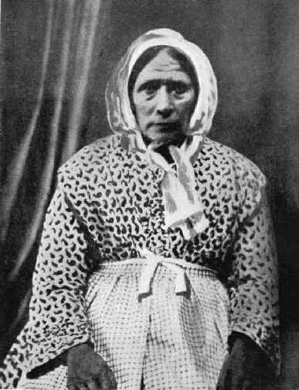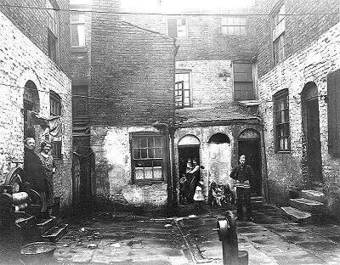The shipping trade brought lots of new businesses to Liverpool. Because of this, people moved to Liverpool for **more jobs**, better **pay** and a **better life**.   
  
Because so many people moved to Liverpool so **quickly**, there wasn’t enough houses for people to live in.   
  
To solve this, small, quickly-built houses were created. These **slum** houses were dark, damp and overcrowded, with **no inside toilets**.

Everyone used a shared **outside pump** to get **water** from. Cholera is a deadly disease that spreads through **bacteria** in water. It spread quickly.  
  
The spread of cholera was stopped by a woman named **Kitty Wilkinson.** She set up a **wash-house** and **laundry** that people could wash themselves and their clothes. It helped **reduce the spread** of the cholera bacteria.

In Victorian times most worked in **factories** instead of going to **school**. Schools were often just one small building with just one classroom. One class could have lots of **different** **ages** in it.   
  
The teachers were **very strict** and would often **hit** children very hard if they did not do as they were told.

**Questions are on the next page**

Poverty and disease in Victorian Liverpool **Questions**

|  |
| --- |
| 1. **Why** did so many people **move** to Liverpool in Victorian Times? |

|  |
| --- |
| 2. **What** do you think **life would be like** living in a poor **slum house**? |

|  |
| --- |
| 3. What is **cholera** and how did it **spread**? |

|  |
| --- |
| 4. What did **Kitty Wilkinson** do to help **stop Cholera**? |

|  |
| --- |
| 5 Describe what a **Victorian classroom** would have been like. How is it different to YOUR classroom? |