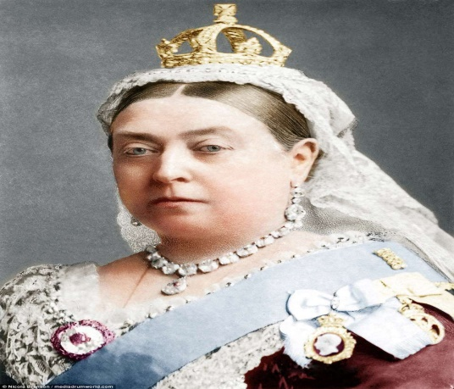
Changes in Victorian Liverpool (Worksheet Version 2)
During Queen Victoria’s reign, Britain ruled over a quarter of the world. Because Liverpool was a major shipping and business district, it became the second most important and richest city in the world after London.
When the eighteen-year-old Queen Victoria came to the throne
in 1837 Liverpool’s population was 160,000 people.
By the time she died in 1901 the population had increased to 700,000.
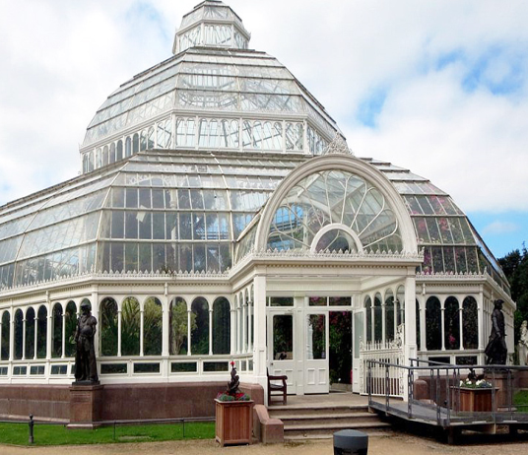
Many incredible buildings, like St Georges Hall, were built during this time including. The Oriel Chambers Building is the first in the world to be built with an Iron Frame and the Tobacco Warehouse is the largest brick-built building in the world (with 27 million bricks)
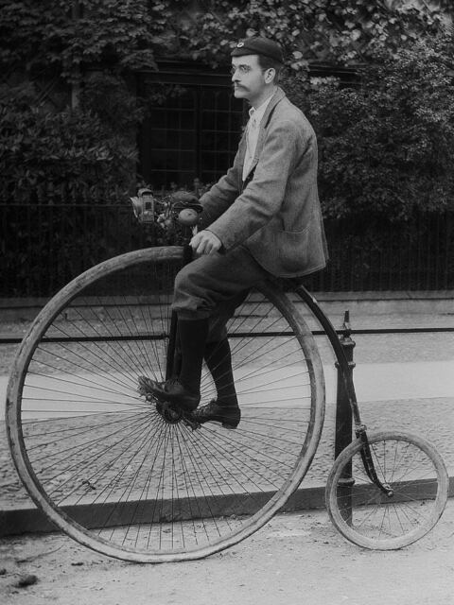
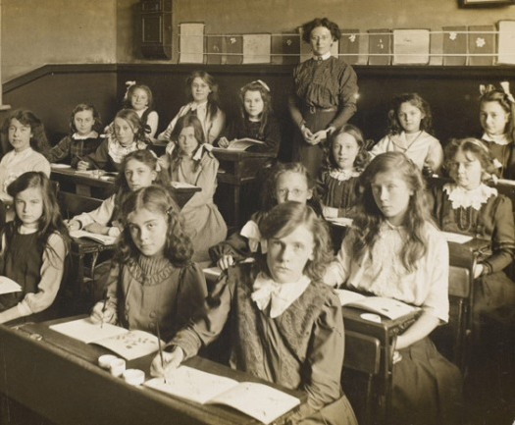
Many huge mansion houses were built for the wealthy to live in. New parks and gardens (Like Sefton Park, Newsham Park and Stanley Park) were also created.
Victorian Liverpool saw the Grand National Horse race begin
at Aintree and also the creating of the world’s first Football League,
with Everton being founding members in 1878. Soon after in 1892 Liverpool FC formed. The city also boasts the world’s oldest Rugby club. Also, Liverpool athlete John Hulley also set up the country’s first modern Olympic Games.
Also during this period, new libraries, hospitals and public baths
were created in Liverpool for the first time. Rather than working in factories, more and more children started going to school. Laws were introduced to limit the age they could work and how many hours they could work for.
The world became more exciting with new inventions arriving. Photography, recorded sound, cinema, the bicycle, street lighting, the light bulb, the postal service, trams and telephones all improved people’s lives in Victorian Liverpool.

Questions are on the next page

Changes in Victorian Liverpool Questions
1. How many years in total was Queen Victoria on the throne for?

2. How old was she when she died?
3. By how much did Liverpool’ s population increase at this time?
3. What changes happened in Sport at this time?

2. In addition to the Victorian Buildings and Parks listed, what ones do YOU know?

4 How did the lives of children improve in Victorian times?

5. Look at the list of new inventions from the time. Which do you think was the most important and why?

