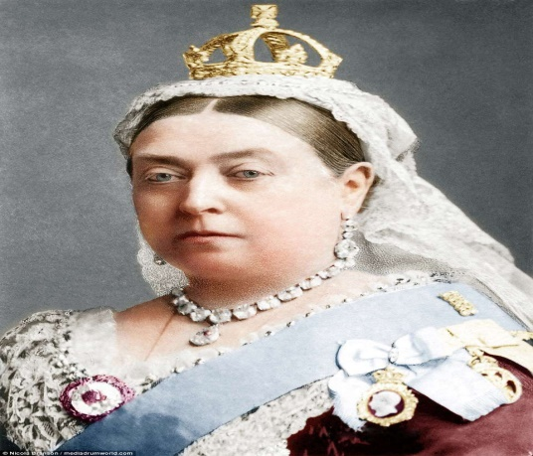
Changes in Victorian Liverpool (Worksheet Version 1)
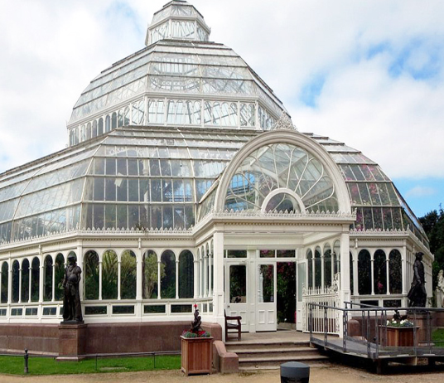
Queen Victoria was 18 when she came to the throne in 1837. She died 64 years later.
Many incredible buildings were built in Liverpool, like St Georges Hall. Some became world famous, like the Tobacco Warehouse, which is the largest brick-built building in the world (with 27 million bricks)
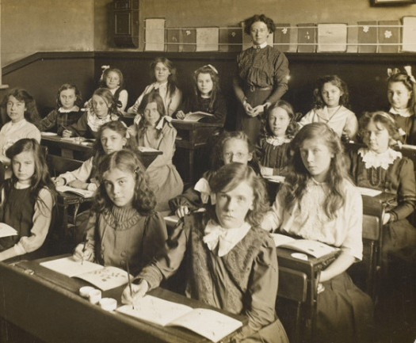
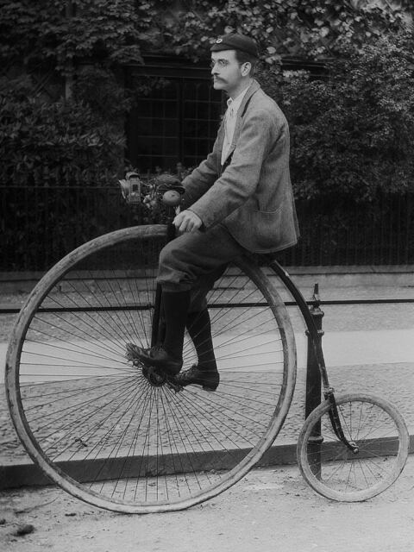
New parks and gardens (Like Sefton Park, Newsham Park and Stanley Park) were also created.
The Grand National Horse race begin. Also in 1878, Everton became founding members of the world’s first Football League. Liverpool joined in 1892. The city also has the world’s oldest Rugby club.
New libraries, hospitals and public baths were created in Liverpool for the first time. Children started going to school instead of working in factories.
The world became more exciting with new inventions arriving. Photography, recorded sound, cinema, the bicycle, street lighting, the light bulb, the postal service, trams and telephones all improved people’s lives in Victorian Liverpool.
Questions are on the next page
Changes in Victorian Liverpool Questions
1. What year did Queen Victoria die? (Clue – add 64 years onto 1837)

2. In addition to the Victorian Buildings and Parks listed, what ones do YOU know?

3. What changes happened in Sport at this time?

4 How did the lives of children improve in Victorian times?

5. Look at the list of new inventions from the time. Which do you think was the most important and why?

