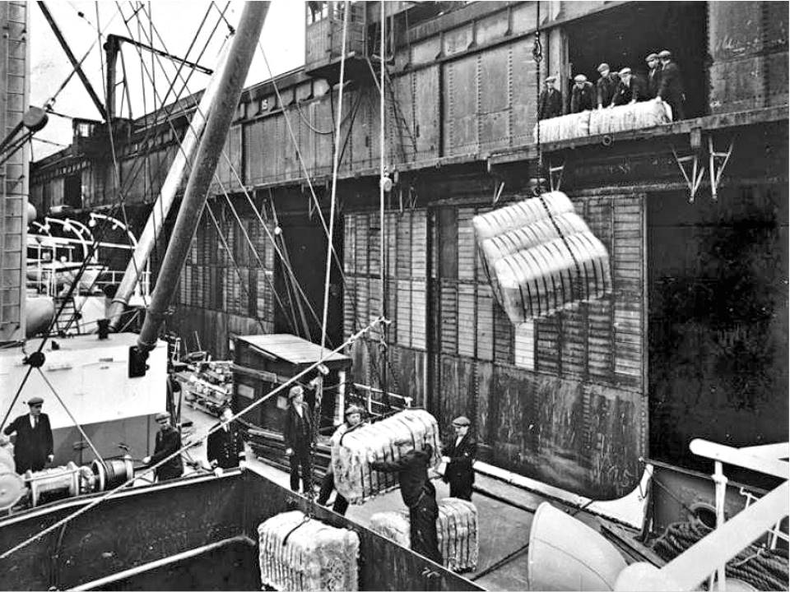Canals Worksheet (Version 2)
The Canals were the roads of the Industrial Revolution. They linked the Liverpool docks to the Mills in Manchester and onto the rest of the country.
Massive heavy goods like cotton, sugar and tobacco came into the country from ships that sailed into Liverpool. However, the cotton mills that made the raw cotton into sheets and fabric were all in Manchester and Lancashire, so the goods needed transporting there.
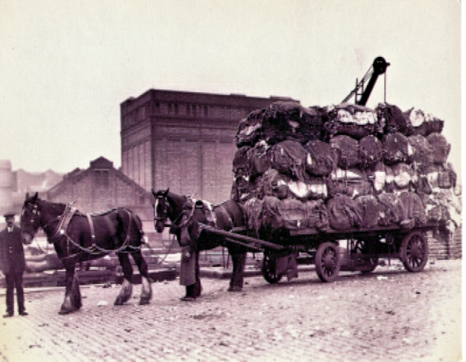
Before canals, the only way of transporting goods around the country was by horse drawn-carts.
The roads that did exist could not handle the weight of the raw cotton, so canals were invented to move heavy objects over large distances.
Canals were narrow and very straight man-made rivers. They were deep enough to cope with canal boats (barges) which were capable of moving nearly forty tonnes of weight. This was far more than a pack of horses could carry or a horse and carriage.
Horses were still used to drag the canal barge along.
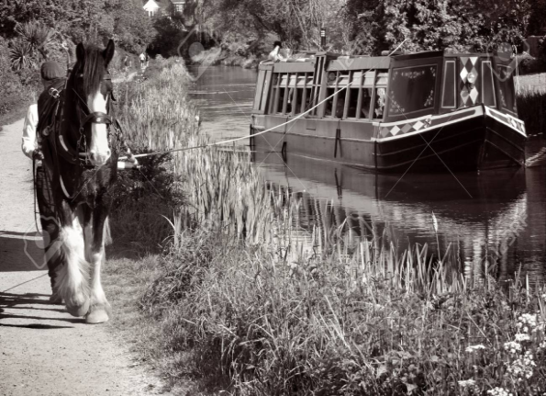
As businesses grew in the North and Midlands, there was a need for waterways where no rivers flowed. The river Mersey flows between Liverpool and Manchester, but it is a tidal river and moves up and down and was therefore difficult to load barges on.
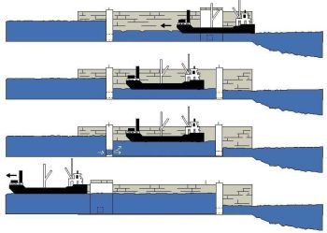
Canals did not have a tide or waves. Also, they were a very gentle ride compared to the Mersey.
Canals travelled in mostly straight lines, but the land itself goes both uphill and downhill. To help the barge move along parts of the country that are higher or lower than others, locks were invented.
The lock allows the barge to enter at one level and leave at a different level. It traps the barge inside two gates whilst the water fills and empties around it. (see diagram right)
The first major canal built was the Sankey Canal in St Helens that was built in 1757. It was used to transport goods between Liverpool, Warrington, St Helens and Widnes.
Soon after a whole network of canals linked the whole country up
until the arrival of the railways which gradually replaced them.
Questions are on the next page
Canals Questions

1. What were the heavy materials that would be transported from the Liverpool docks to Manchester?

2. Before canals, how were goods transported around the country?

3. Why were canals invented?

4. How do canal locks work?

5. When and where did the first canal open?

