Canals Worksheet (Version 1)



Canals are similar to small rivers,   
except that they are **made by people**.

They were made for boats to travel on.  
These boats are called **barges**.  
  
   
Barges carried **heavy goods** like cotton, sugar and tobacco.  
  
Canals are **easier** to travel on than a **river**.

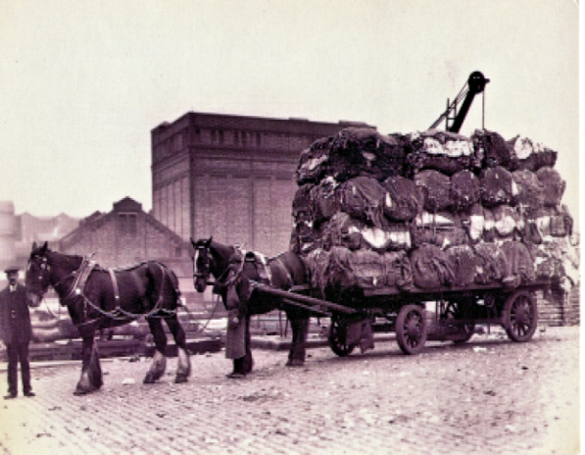Before canals things could only be moved using **horse and cart.**

The canals mainly linked the **Liverpool docks** to the **Manchester cotton mills**.

Canals are made in **straight lines**.

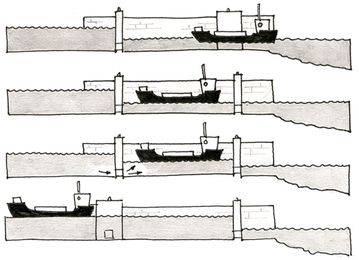  
Sometimes the land goes **uphill** and **downhill**.   
To help the barge move up and down it uses a **lock**.  
  
  
The lock allows the barge to **enter** at **one level**   
and **leave** at a **different level**.   
  
  
It **traps** the barge inside two gates. The water then **fills** and **empties** around it.   
  
  
The first was the **Sankey Canal** in St Helens that was built in **1757**.   
  
  
It was used to transport goods from **Liverpool**.

**Canals Questions**

|  |
| --- |
| 1. What is the **boat** on a canal called? |

|  |
| --- |
| 2. **Before** canals, **how** were goods transported around the country? |

|  |
| --- |
| 3. What **goods** did canals help to move? |

|  |
| --- |
| 4. **What** does a canal use when the land goes **up or down hill**? |

|  |
| --- |
| 5. **When** and **where** did the **first canal** open? |