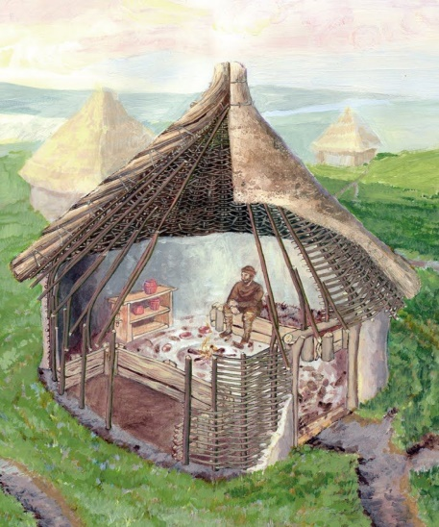
Stone Age Homes.
During the Palaeolithic Age, people only hunted and gathered they did not have shelters and lived in caves or under trees. The constantly moved to follow where the food (animals) went. Inside their caves they painted pictures of the way they lived and many of these paintings still survive today.
Mesolithic people learnt to build basic huts from poles covered by animal skin or straw. They were nomads, which means they rarely settled in places and usually lived in temporary campsites near water sources like rivers and streams. Archaeologists have found the remains of their camps by finding small holes in circles left in the ground.
By the Neolithic age, the single huts had developed small villages, they could farm animals and also buried their dead in graves. Often the dead were buried with food, weapons and jewellery.
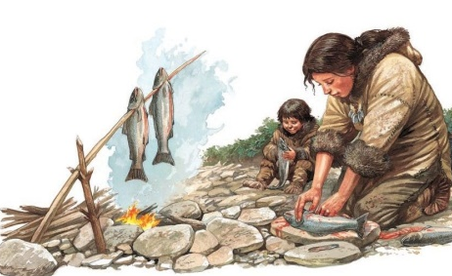
Stone Age Food
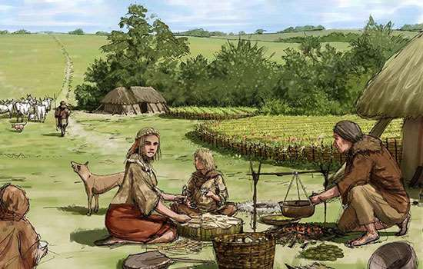
Palaeolithic people ate food as they found it. They were hunter gatherers who got their food by hunting animals such as deer and boar. They would also find food in the forests like berries, nuts or wild vegetables.
Mesolithic people, however, learnt to keep some of their food (nuts and dried berries) for over the winter when little grows. They also learn how to catch fish in nets and had small canoe boats. They also learnt how to cook meat.
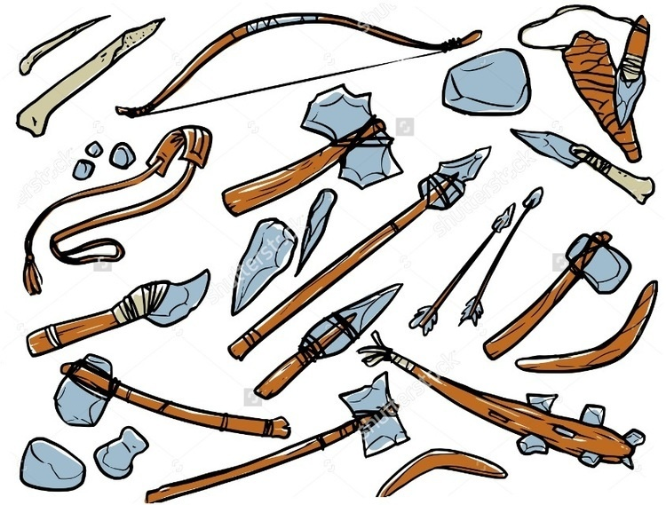
By the Neolithic period, people had learnt how to plant seeds and grow crops. They also learnt to keep animals in small enclosures like farms.
Stone Age Tools
Palaeolithic Mesolithic tools were just pieces of smashed up stone. The stone was usually flint which has a sharp edge to it.
In the Mesolithic era, people could take these pieces of sharp stone and wrap them onto sticks. These could then be used as spears for hunting or basic hammers for making shelters.
By the Neolithic period, people had learnt how to carve the stones into arrow heads and very small fishing hooks. They could also smooth the stones into jewellery and necklaces.
Items dug up from the ground today help us to learn about the Stone Age. The types of tools used and how complex they are tells us what era they are from. Also the fossiled remains of nuts, berries tells us what people ate. Evidence of burning tells us if they cooked food or not. Also bones left behind tell us what animals they ate.
Questions on the other side…
Stone Age Life Questions
Why did Palaeolithic people constantly move about?

How were people in Mesolithic times better hunters?

Why did people not need to move around as much in Neolithic times?

How do we learn about the Stone Age?

