



The Stone Age is divided into **three** parts (eras):

* The Old Stone (**Palaeolithic** Age)
* The Middle Stone (**Mesolithic** Age)
* The New Stone (**Neolithic** Age)

C:\Users\user\Google Drive\1HistoryofLiverpool\1stoneage\divider.png

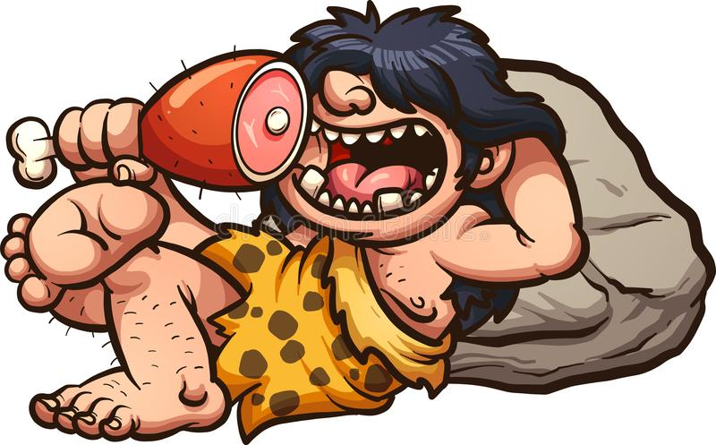**The Palaeolithic Age**

* The Palaeolithic Age was about **50,000** years ago.
* People lived in **caves** because the country was covered in **ice** and snow.
* People used small **flint stones** for cutting meat with.
* They **moved around** to find their food.
* If they found an animal, they would eat it **instantly**.
* They could **paint** on walls.

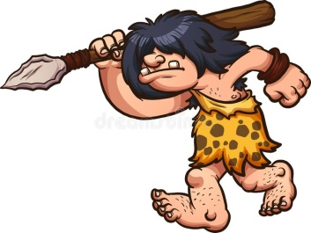**The Mesolithic Age**

* The Mesolithic Age was about **10,000** years ago
* People lived in **huts** made from straw, wood and mud.
* They hunted with **spears** made with stone arrow heads.
* They started to **store** food for over the winter.
* They kept **dogs** as pets.
* They could make **pottery**.

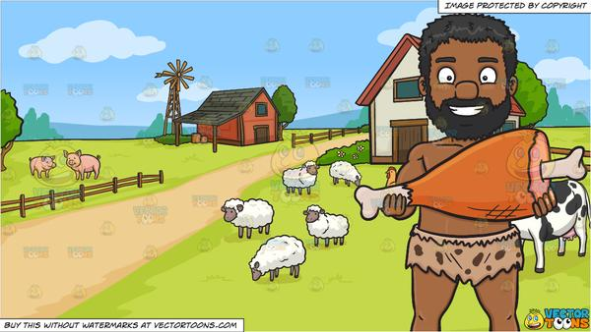**The Neolithic Age**

* The Neolithic Age was about **6000** years ago.
* People started to live in small **villages**.
* They hunted with **bows** and arrows and caught fish in **nets**.
* They could plant **seeds** to grow crops.
* They kept animals contained on small **farms**.
* They could make **jewellery**.

The Stone Age came to an end when people learnt how to use **metal** to make tools instead of stone.  
Roughly **5000** years ago.

**Questions on other side…**

**Stone Age Questions**

What are the **names** of the **three** Stone Age **eras**? (parts)

1.

2.

3.

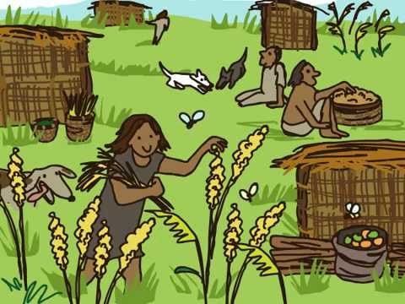

**What** does this picture show you about  
**life in Neolithic Age**?

**When** and **how** did the Stone Age **come to an end?**

**What** had people **learned to make** by the **Neolithic Age**?

**How** did people **survive winter** in the **Mesolithic** Age?

**How many** thousand years ago was the **Palaeolithic** Age?