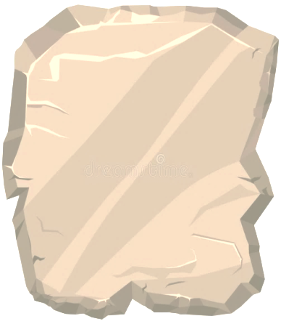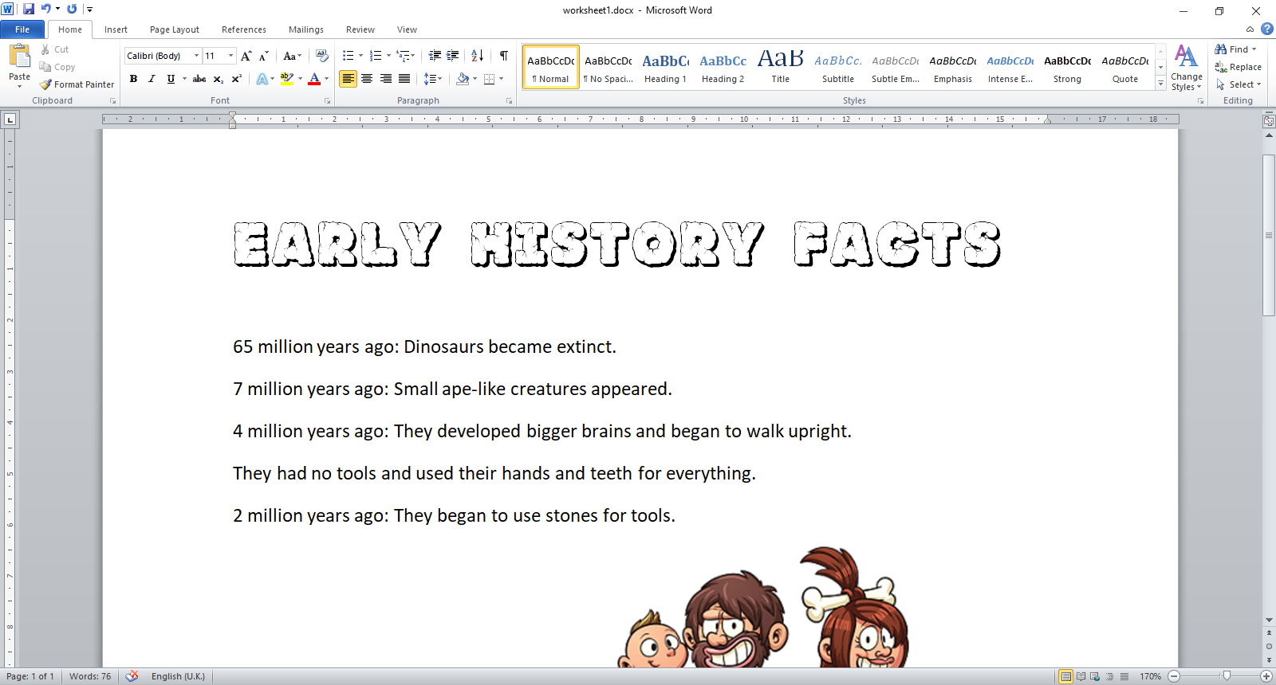

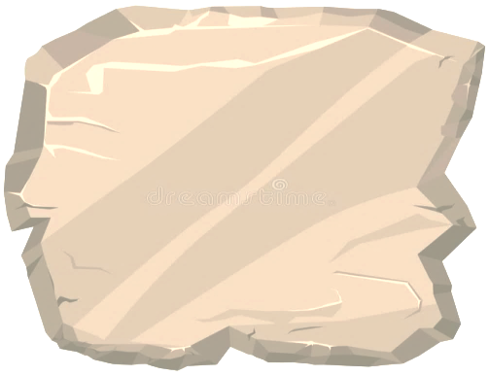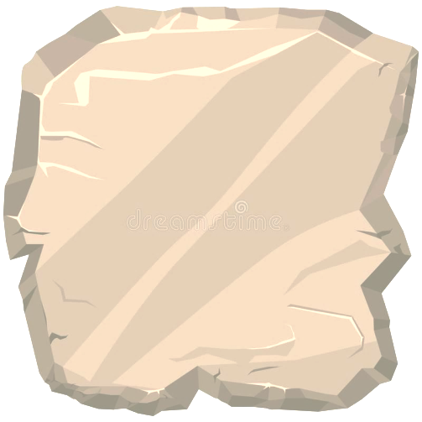

**65 million  
years ago**:   
  
Dinosaurs became **extinct**.

**4 million years ago**:   
  
The people changed   
to have **bigger brains**and began to **walk upright**.

They had **no tools** and used their **hands** and **teeth** for everything.



**7 million   
years ago**:   
  
Small **ape-like** people appeared.



**2 million years ago**:   
  
They began to use **stones** for tools.

They used broken pieces of **flint**   
which had **sharp edges** for cutting.

This is why we call this era the **Stone Age**.



|  |
| --- |
| **When** did dinosaurs become extinct? |

|  |
| --- |
| **When** did small ape-like people appear? |

|  |
| --- |
| How did these people **different** to the Stone Age people before them? |

|  |
| --- |
| Why was this era called the **Stone Age**?  **Caveman Images - Cartoon Caveman (500x300), Png Download** |

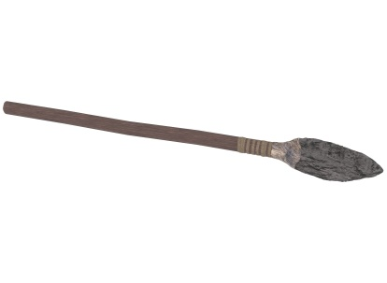

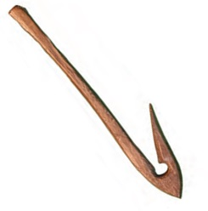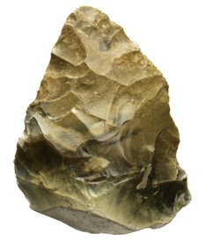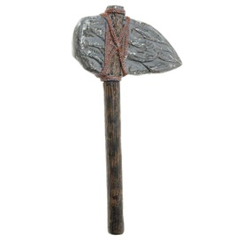

Stone Age people did not have shops, they had to **make** everything themselves.   
The materials they had were all **natural**.   
Things like, stone, bone, rope, straw, shells leather and clay.

Your task is to design **YOUR OWN** Stone Age tool. It can be a weapon, something to hunt or eat with, jewellery or even something to play music on! You can **only use** the material listed above.

|  |
| --- |
| YOUR OWN STONE AGE TOOL  **List the Materials you used:**  **What would it be used for?** |